**Github:**

* Github.com/AnthonyYos/IoT
* github.com/aaackc
* github.com/s0720bae
* github.com/Alshaikh1abbas

**Video:**

https://www.youtube.com/watch?v=G7MyKo9cvGs&feature=youtu.be

**Introduction:**

The goal of ICP 5 was learning how to use Node Red and use it to receive weather data, using Openweathermap, and send the data via twitter and email.

**Approaches/ Methods:**

First we needed to learn how to use install and learn how Node Red works. After which we needed to create the flow for our application. We got our weather data from Openweathermap using an api key they provide, and then we also went to twitter to get the api keys that would allow us to send a tweet through Node Red.

**Workflow:**

1. Create our flow for Node Red
   * timestamp -> openweather -> extractMessage ->
     + Email
     + Twitter
     + msg.payload
2. Signed up for api key on Openweathermap and twitter, then copy the keys to Openweather and twitter nodes
3. Deployed the flow, inject, and then checked both twitter and the email.

**Flow Diagram:**

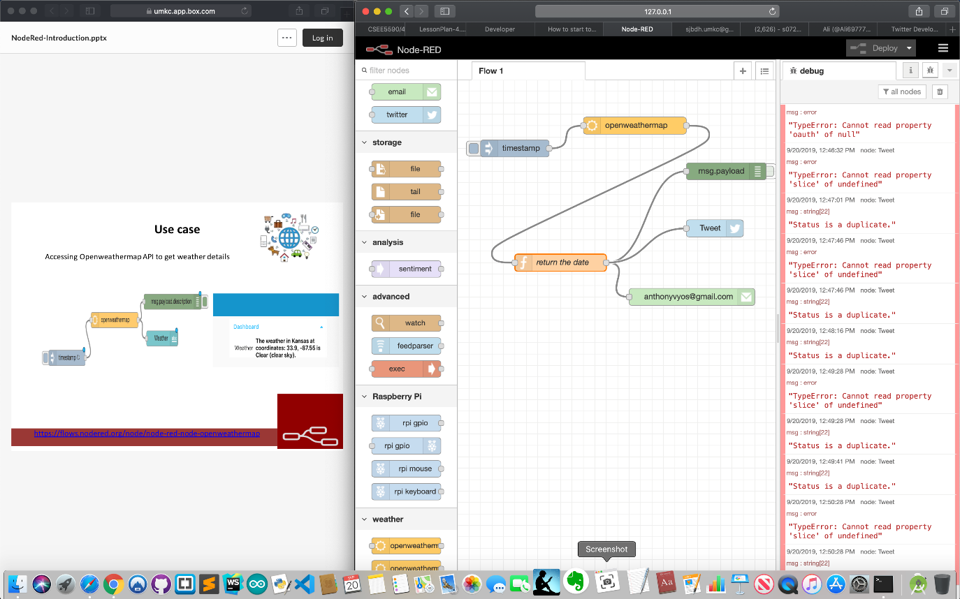

**Parameters:**

* Wrote function that would extract our weather data. 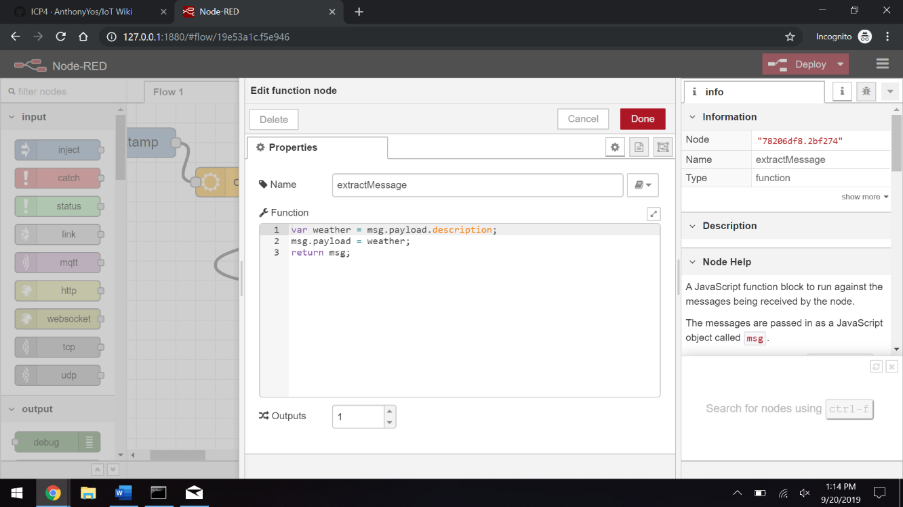
* Added api key from openweathermap and twitter. 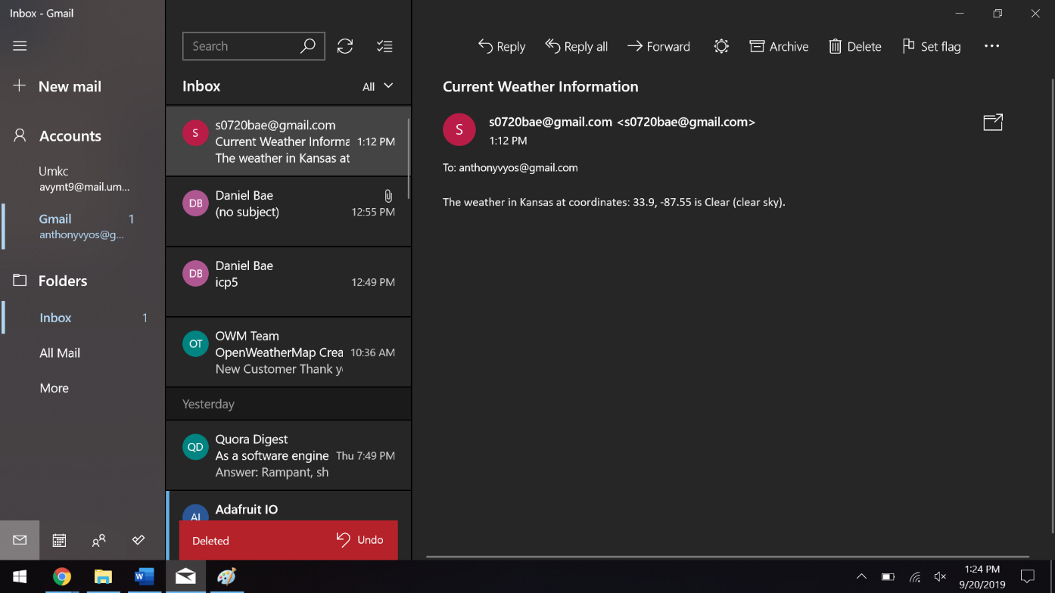 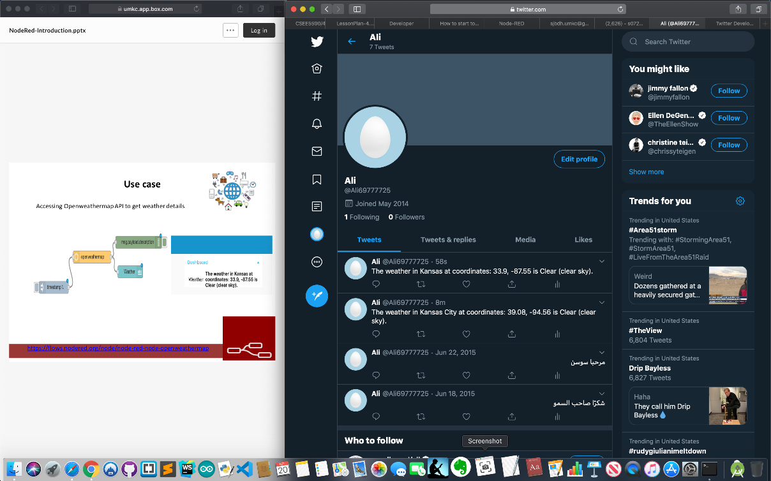

**Evaluation & Discussion:**

There were difficulties on getting the api key from openweathermap to work, as well as trying to get the api keys from twitter. Most of our time was on getting our api key from openweathermap to work and then figuring out how to properly extract the data we needed. Then after resolving those issues we had trouble getting the api keys from twitter. Some time later, we got access to those keys and were able to deploy our application.

**Conclusion:**

We were introduced the basics of Node Red of how nodes connect to each other and how they interact. We also learned how to receive weather data from an api and use the data we received to send weather updates via twitter and email. Through this we saw some basic applications of how we can receive data and share data, as well as how this can be extended onto different social platforms or be sent through other forms of communication.